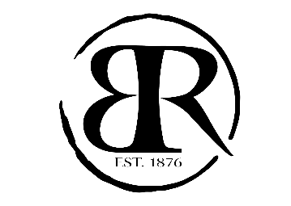

***Christmas Set Menu***

***Entrée***

*Porcini Mushroom & Parmesan Arancini, aioli (v)*

*Lamb & Halloumi Skewer, romesco sauce*

*Vegetable Pakora, eggplant yoghurt (v)*

***Main***

*Black Angus Sirloin, (Cape Byron NSW) 250g grass fed, mushroom ragu, hand cut chips, red wine jus*

*Salmon Fillet, pan fried, kipfler potato, kale, lentils, pumpkin, romesco sauce*

*Four Cheese Ravioli, broccoli, zucchini, oven dried tomato, basil pistou and parmesan (v)*

***Dessert***

*Warm Fondant Brownie salted caramel sauce, vanilla ice cream*

*Lemon Tart, vanilla ice-cream, chocolate sauce*

*Tea or Coffee*

***Two Course $49 / Three Course $59***